* In the **GitDemo** folder, we create a **error.log** file and a log folder having a sample.txt file inside.
* Inside **.gitignore** we add the following lines –

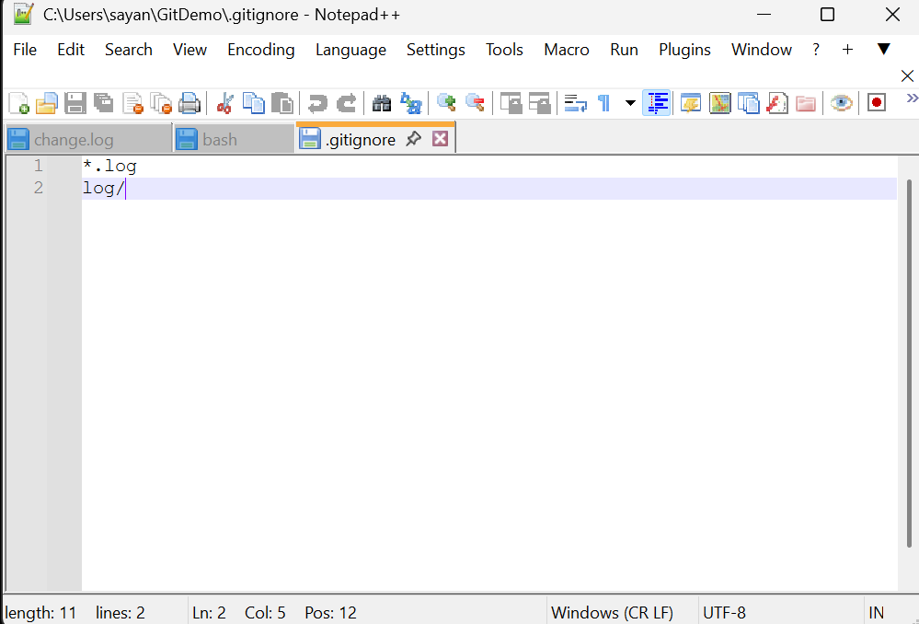

*.log -> excludes all files having .log extension

log/ -> ignores the log folder

The following commands are executed ->

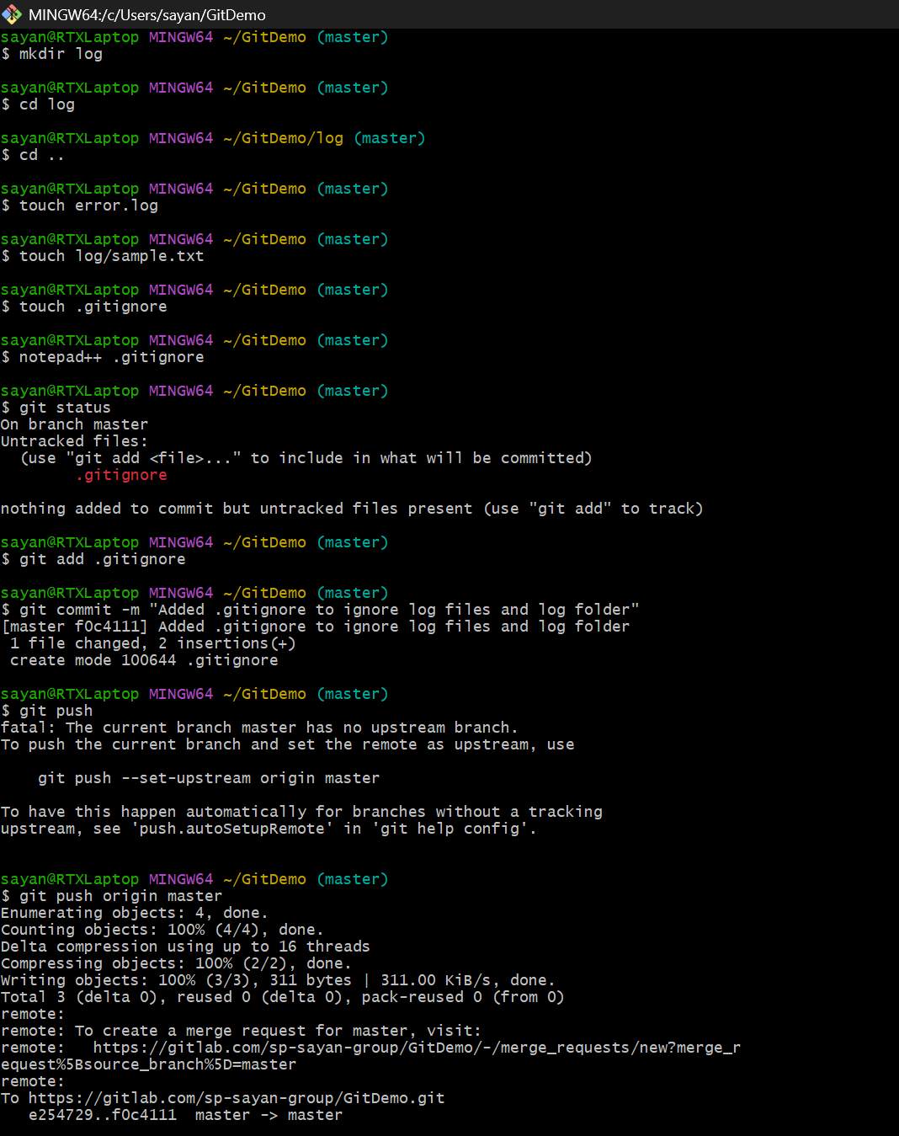

* **In GitLab,**

